Branch and Bound

Web Experiment #3

Kahekahe Kakai

Experiment Description

Determine the exact answers to the ten random 25 cities files of **.
Record the correct distances in an array d, where d[j] is the distance for
file j. Start BandB with a fake seed of length k*d[j],j=1,...,10,
where k = .1, .2, .3, .4, .5, .6, .7, .8, .9,
Record the time it takes for BandB to terminate.
Repeat with a fake seed of length k*d[j],j=1,...,10
where k = .91, .92, .93, .94, .95, .96, .97, .98, .99,
Record the time it takes for BandB to terminate.

These experiments produces 180 data points.
Explain how to use this data to "predict" d for the file.
Explain how to use this experiment to predict d for a file
where d is NOT known.

Experiment Summary

The experiment shows how using Branch and Bound and some seed value we can generate approximations of the actual value. As the seed value approaches the real value the time to termination will increase seemingly exponentially at which time an extrapolation can be made as to the real value.

Below is a table of the data that I generated.

Table 1
FileName | 0.1 | 0.2 | 0.3 | 0.4 | 0.5 | 0.6 | 0.7 | 0.8 | 0.9
a_25_1 | 0.024 | 0.02 | 0.02 | 0.02 | 0.021 | 0.02 | 0.02 | 0.021 | 0.137
a_25_2 | 0.022 | 0.02 | 0.02 | 0.021 | 0.021 | 0.021 | 0.021 | 0.021 | 0.177
a_25_3 | 0.022 | 0.022 | 0.02 | 0.02 | 0.021 | 0.021 | 0.021 | 0.021 | 0.028
a_25_4 | 0.022 | 0.021 | 0.021 | 0.021 | 0.021 | 0.021 | 0.021 | 0.024 | 0.229
a_25_5 | 0.022 | 0.021 | 0.02 | 0.02 | 0.021 | 0.021 | 0.021 | 0.021 | 0.113
a_25_6 | 0.022 | 0.02 | 0.021 | 0.02 | 0.021 | 0.02 | 0.021 | 0.021 | 0.038
a_25_7 | 0.022 | 0.021 | 0.02 | 0.021 | 0.021 | 0.02 | 0.02 | 0.023 | 0.29
a_25_8 | 0.022 | 0.021 | 0.021 | 0.021 | 0.021 | 0.02 | 0.02 | 0.021 | 0.096
a_25_9 | 0.022 | 0.021 | 0.021 | 0.021 | 0.021 | 0.021 | 0.02 | 0.021 | 0.031
a_25_10 | 0.024 | 0.02 | 0.02 | 0.02 | 0.02 | 0.021 | 0.021 | 0.02 | 0.029

Table 2
FileName | 0.91 | 0.92 | 0.93 | 0.94 | 0.95 | 0.96 | 0.97 | 0.98 | 0.99
a_25_1 | 0.197 | 0.249 | 0.385 | 0.592 | 0.891 | 1.311 | 1.947 | 2.797 | 3.974
a_25_2 | 0.285 | 0.408 | 0.625 | 0.942 | 1.434 | 2.154 | 3.316 | 4.981 | 7.524
a_25_3 | 0.043 | 0.044 | 0.048 | 0.052 | 0.067 | 0.1 | 0.125 | 0.174 | 0.26
a_25_4 | 0.295 | 0.417 | 0.553 | 0.736 | 1.022 | 1.363 | 1.918 | 2.57 | 3.141
a_25_5 | 0.192 | 0.253 | 0.363 | 0.476 | 0.651 | 0.922 | 1.272 | 1.736 | 2.398
a_25_6 | 0.056 | 0.059 | 0.075 | 0.091 | 0.24 | 0.151 | 0.189 | 0.248 | 0.332
a_25_7 | 0.433 | 0.775 | 0.902 | 1.323 | 1.712 | 2.457 | 3.245 | 4.548 | 6.42
a_25_8 | 0.139 | 0.221 | 0.272 | 0.419 | 0.585 | 0.796 | 1.051 | 1.564 | 2.145
a_25_9 | 0.054 | 0.059 | 0.076 | 0.106 | 0.148 | 0.206 | 0.299 | 0.446 | 0.641
a_25_10 | 0.031 | 0.035 | 0.038 | 0.053 | 0.171 | 0.072 | 0.098 | 0.105 | 0.12

In Tables 1 and 2 we read the data that was generated by the experiment I conducted. I first ran branch and bound and got the answer for all the test files that we used. I then initialized an array in the code to store those values and then according to which file we were running the program would pull out the appropriate correct value multiply it by the constants that are at the head of each column in the table and then recorded the termination time of the algorithm. While the data in the table exhibit a trend that we wished to demonstrate we will use Graph 1 to analyze the results as the graphing of the data makes the increasing time trend more obvious.

Graph 1

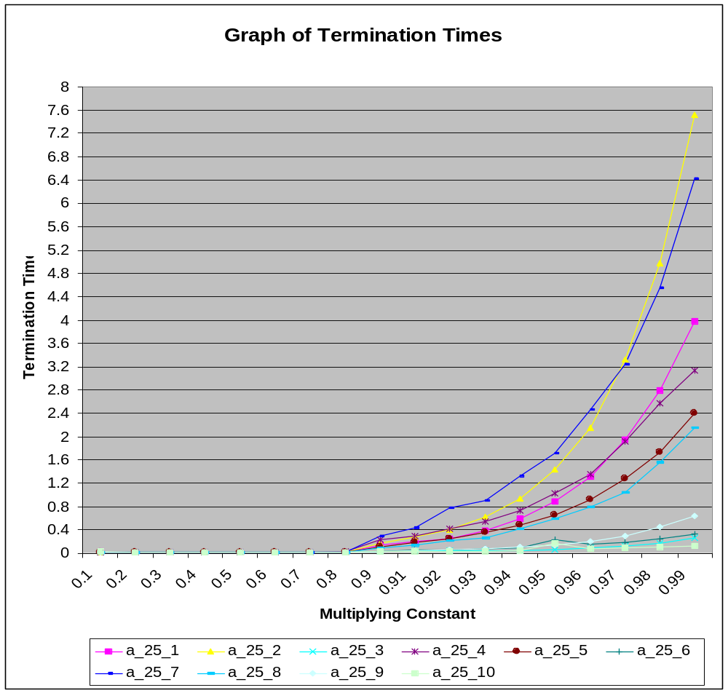

Graph 1 shows that as our upper bound gets closer to the actual value for the file the Branch and Bound algorithm will run significantly longer. This is due to the fact that the kill rules kill everything when we seed to low and so the algorithm finishes in some cases after pushing one value onto the heap. As we approach the actual value the kill rules cannot kill as early or as many children and so the time to termination grows in an exponential form. To get the actual values for this data we could observe a number of things about the trends and make a guess as to what the value was. We can always take the calculated seed and divide by the muliplying constant to get the original value. It is easy to get the right answer when you know the right answer, but it is obviously not nearly as easy when the answer is unknown and the cost in terms of time is great to get it. This experiment used with branch and bound allows us to find a way to get a better approximation of the answer in an acceptable amount of time. To do this we could start out with some seed value whether it be random or through some intuitive or otherwise informed guess. We would then apply a series of mutiplying constants one by one starting out very low and gradually increasing as we detect the trends that will occur in the experiment. As we see the time to termination increase we could then lower the steps between constants and try to approximate the value while staying within the time bounds that have been set. We could then use the data generated to do some sort of extrapolation of what the real value is.

